RC Underwater Surveillance ROV Drone

Water covers over 70% of mass on earth. There lies a vast unexplored land beneath the seas. Moreover underwater surveillance, videography plays a vital role in a wide range of applications. From dam and bridge inspections to fishing surveillance to sea life videography and oceanography underwater inspection is a very common need.
Also underwater inspection will help us to keep track of sea life conservation, pollution monitoring in seas as 50 to 80% oxygen we breathe is produced by sea planktons and other sea plants. Extensive damage to seas by pollution and overfishing can cause great damages cross the globe. So here we develop a underwater inspection drone that can navigate easily underwater and allow us to vide live video footage underwater.

The RC underwater surveillance drone provides following advantages including:
- Easy to Navigate Underwater
- 360 Degree Direction Control
- Live Footage Viewing
- Dual Motor Propulsion system
- Lightweight and anti-rust design for long term usage

The RC drone uses 2 x motors for propulsion and a separate motor for depth/direction control. Both motors are attached with propellers to achieve this task. This mechanism makes use of a unique rudderless mechanism using motor drives to control 360 degree movement of the drone. This mechanism does not make use of ballast tanks to control buoyancy.
The drone consists uses the 2 motors to provide front drive as well as for left right direction control. The 3rd motor is used to control the vertical alignment of the drone. This motor in combination with other 2 motors is used to dive in or bring up the drone. All motors and controller unit is enclosed in a water proof chamber.
The drone now uses a camera to capture footages underwater. These footages are transmitted to the floating buoy unit from there user can connect via wifi to check the footages. The system makes use of a raspberry pi controller for footage transfer as well as wifi transmission.
Also the buoy unit is used to pullout the drone in case it gets stuck or runs out of battery under water.

Components:
- DC Motors
- Raspberry Pi
- Shafts
- Propellers
- Camera Module
- Resistors Capacitors
- Diodes & transistors
- PCB Board
- Motor Mounts
- Motor Drivers
- Outer Frame
- Inner Waterproof Frame
- Couplings
- Switches
- Electrical & Wirings
- Mounts and Joints
- Supporting Frame
- Screws and Fittings

Applications:
- Oceanography & Sealife Photography
- Safety inspections of dams, locks, harbours, Remote Islands and Ships
- Inspections of boats / ships
- Lake Inspections

Advantages:
- Easy to Navigate Underwater
- 360 Degree Direction Control
- Live Footage Viewing
- Dual Motor Propulsion system
- Lightweight and anti-rust design for long term usage

Disadvantages:
- Cannot float above water
- Has Limited Battery Life

Block Diagram:

Front View
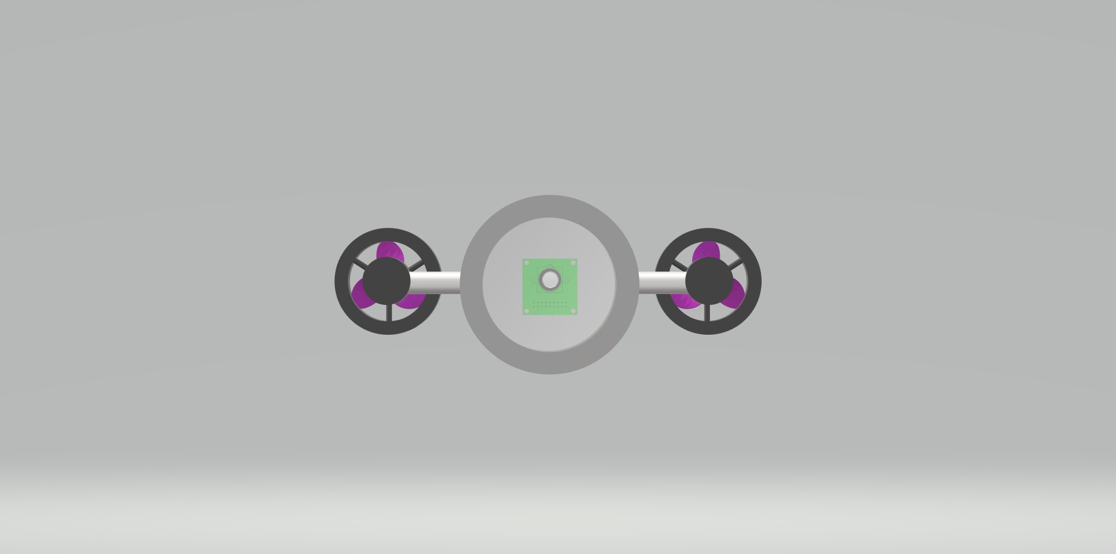

Side View
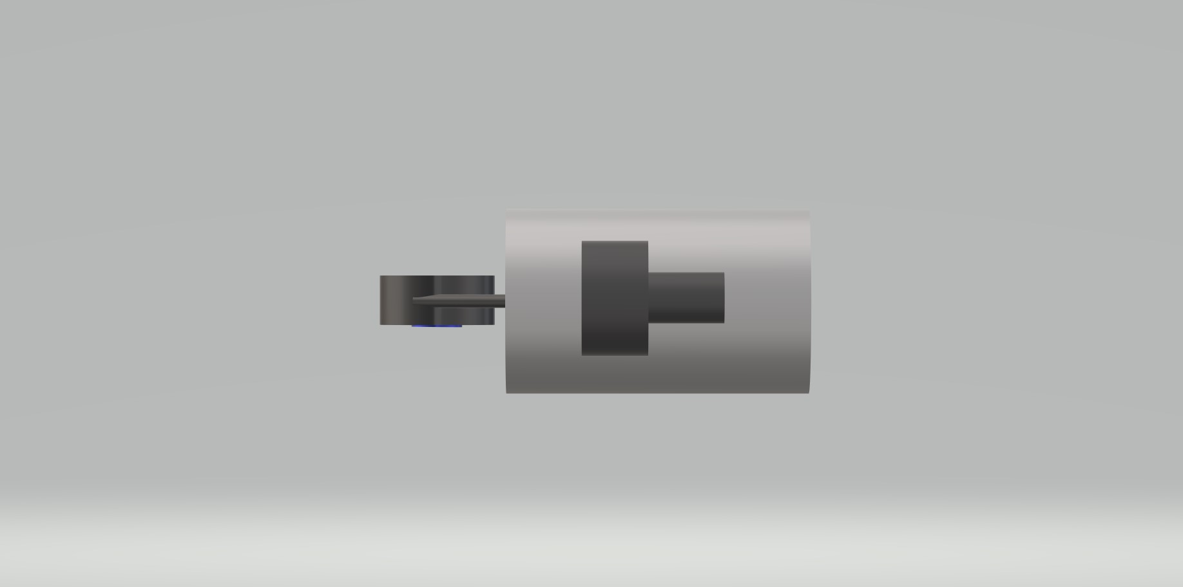

3D View
